Malawi

## Respect for rule of law (ROL) data

The data set shows the data on the respect of the rule of law for the country.

## # A tibble: 19 x 5  
## country iso3c date ruleOfLaw ruleOfLawCategory4   
## <chr> <chr> <dbl> <dbl> <chr>   
## 1 Malawi MWI 1996 -0.377 ROL moderately disrespected  
## 2 Malawi MWI 1998 -0.368 ROL moderately disrespected  
## 3 Malawi MWI 2000 -0.477 ROL moderately disrespected  
## 4 Malawi MWI 2002 -0.419 ROL moderately disrespected  
## 5 Malawi MWI 2003 -0.212 ROL moderately disrespected  
## 6 Malawi MWI 2004 -0.123 ROL moderately disrespected  
## 7 Malawi MWI 2005 -0.105 ROL moderately disrespected  
## 8 Malawi MWI 2006 -0.216 ROL moderately disrespected  
## 9 Malawi MWI 2007 -0.156 ROL moderately disrespected  
## 10 Malawi MWI 2008 -0.110 ROL moderately disrespected  
## 11 Malawi MWI 2009 -0.110 ROL moderately disrespected  
## 12 Malawi MWI 2010 -0.126 ROL moderately disrespected  
## 13 Malawi MWI 2011 -0.155 ROL moderately disrespected  
## 14 Malawi MWI 2012 -0.219 ROL moderately disrespected  
## 15 Malawi MWI 2013 -0.162 ROL moderately disrespected  
## 16 Malawi MWI 2014 -0.286 ROL moderately disrespected  
## 17 Malawi MWI 2015 -0.307 ROL moderately disrespected  
## 18 Malawi MWI 2016 -0.375 ROL moderately disrespected  
## 19 Malawi MWI 2017 -0.370 ROL moderately disrespected

## Respect for rule of law (ROL) trend

The plot shows the trend of the respect for the rule of law for the country.

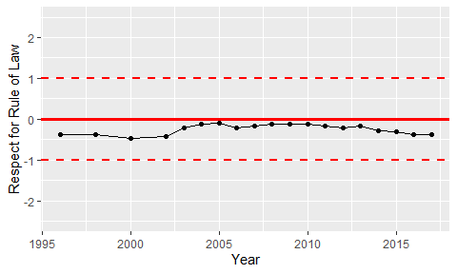

Trend of the Respect for the Rule of Law